Experiment 5: Simulate the lifecycle stages for UI design using the RAD model and develop a small interactive interface using Axure RP

Name:Jovitha J Roll number: 240701219

Aim:

The aim of this experiment is to simulate the lifecycle stages of User Interface (UI) design using the Rapid Application Development (RAD) model and to develop a small interactive interface prototype in Axure RP.
Procedure:

Design Bottom Navigation Panel
Add a navigation bar at the bottom to switch between clock features.
  - Draw a rectangle at the bottom of the screen
  - Add four buttons/icons: Alarm, World Clock, Stopwatch, Timer
  - Convert the bar into a Dynamic Panel with states for each page

Create Alarm Page
Design the first page to set and view alarms.
  - Add text fields for time input
  - Include toggle switches for enabling/disabling alarms
  - Add a list area to display saved alarms
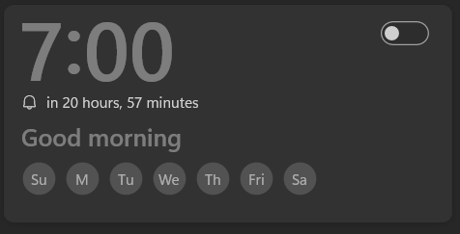

Create World Clock Page
Design a page to show multiple time zones.
  - Add a list widget to display cities and times
  - Include an 'Add City' button
  - Use labels to show current time in selected cities



Create Stopwatch Page
Design a stopwatch interface with start, stop, and reset controls.
  - Add a digital time display
  - Include buttons for Start, Stop, Reset
  - Use interactions to simulate time counting

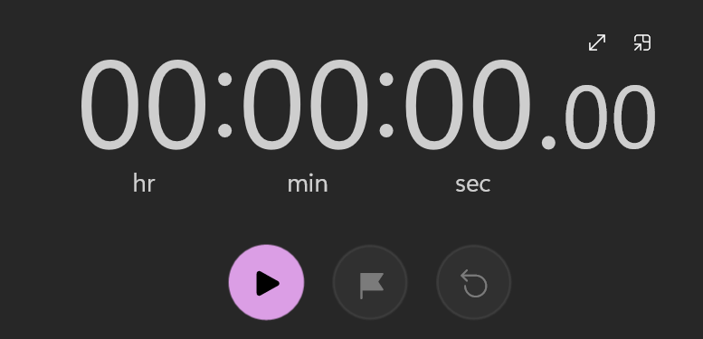

Create Timer Page
Design a countdown timer interface.
  - Add input fields for hours/minutes/seconds
  - Include Start and Reset buttons
  - Display remaining time dynamically
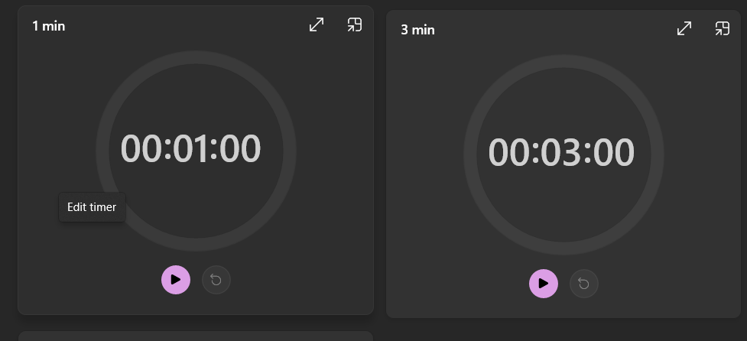

Design Popup Menu
Create a popup menu with various options.
  - Add a Dynamic Panel for the menu
  - Include options like Settings, Help, About
  - Add a close button or allow clicking outside to dismiss




Result:
The experiment demonstrated how the RAD model supports rapid prototyping of a clock UI with multiple functional pages in Axure RP. Iterative design enabled smooth integration of Alarm, World Clock, Stopwatch, and Timer features with intuitive navigation. The popup menu enhanced usability, showing that RAD’s user-centric approach accelerates effective interface development.

